Introduction to Cloud Solutions Lab Report
Use this template to document your work as you complete the lab assignment in QA.

Your Information
Your Name:
Lab Title: Revising, Provisioning and Versioning CloudFormation Templates

Instructions
Follow the instructions to answer the questions related to the lab and add the required screenshots. Submit your completed report following the instructions in Canvas.

Section Validating an Existing AWS EC2 Instance CloudFormation Template
- Step 15 Screenshot: IC template import with S3 URL
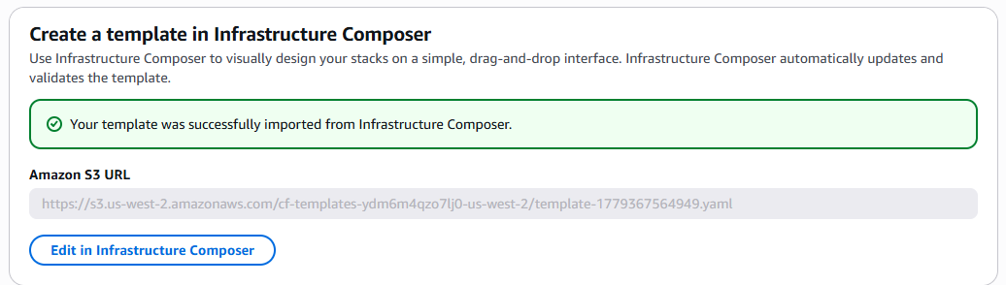

Section Committing Your Template File Changes to GitHub
2. Step 9 Screenshot: GitHub push results
I got frustrated and didn’t even think to screenshot. My bad.

3. Step 11 Screenshot: GitHub master branch including ec2-working.yaml template
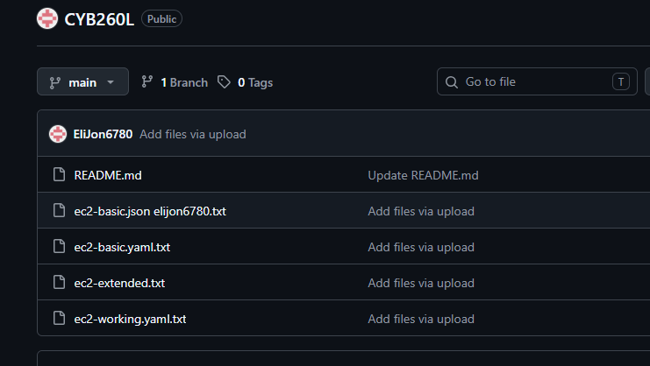

Section Committing Your Template File Changes to GitHub
4. Step 15 Screenshot: IC template import with S3 URL
